- We estimate the conflict in the Middle East will add 0.4ppts to UK inflation in 2026. Higher oil prices will quickly feed through to petrol prices, while a rise in European gas prices will see a sharp increase in household energy bills in July. We will nudge down our below-consensus GDP growth for 2026, as the weaker picture for real incomes weighs on consumer spending.
- The more uncertain inflation environment likely takes a March interest rate cut off the table. If the conflict is short and energy prices quickly fall back, the Monetary Policy Committee will probably resume cutting in either April or June. But if the surge in energy prices persists or expands, the MPC will be set for an extended pause.
Ordinarily the Office for Budget Responsibility's Spring forecast would have dominated this week's economic news. But the conflict in the Middle East rendered the OBR's forecast out-of-date before it was published. The situation remains fluid, and there's considerable uncertainty surrounding the intensity and duration of the conflict. But we will publish updated UK forecasts incorporating this week's developments as part of our global forecast update on March 10.
Our new baseline forecast will assume that the disruption to shipping through the Strait of Hormuz lasts for up to two months. We assume oil prices will average just below $80 per barrel in Q2, up $15 from our February baseline, before prices gradually fall back to a little over $60 per barrel towards year-end. We assume European gas prices will be around 30% higher on average in Q2 than we assumed in our February forecast before slowly normalising.
Under these assumptions, we expect UK CPI inflation to remain above the Bank of England's 2% target for longer, averaging 2.7% this year, compared to our pre-conflict baseline of 2.3% (Chart 1). The pickup in oil prices and weaker pound should quickly feed through to petrol prices. Though the large tax wedge will limit the impact, we still anticipate that higher oil prices will directly lift headline inflation by about 0.1ppt in 2026.
Chart 1: Higher oil and gas prices point to stronger near-term inflation
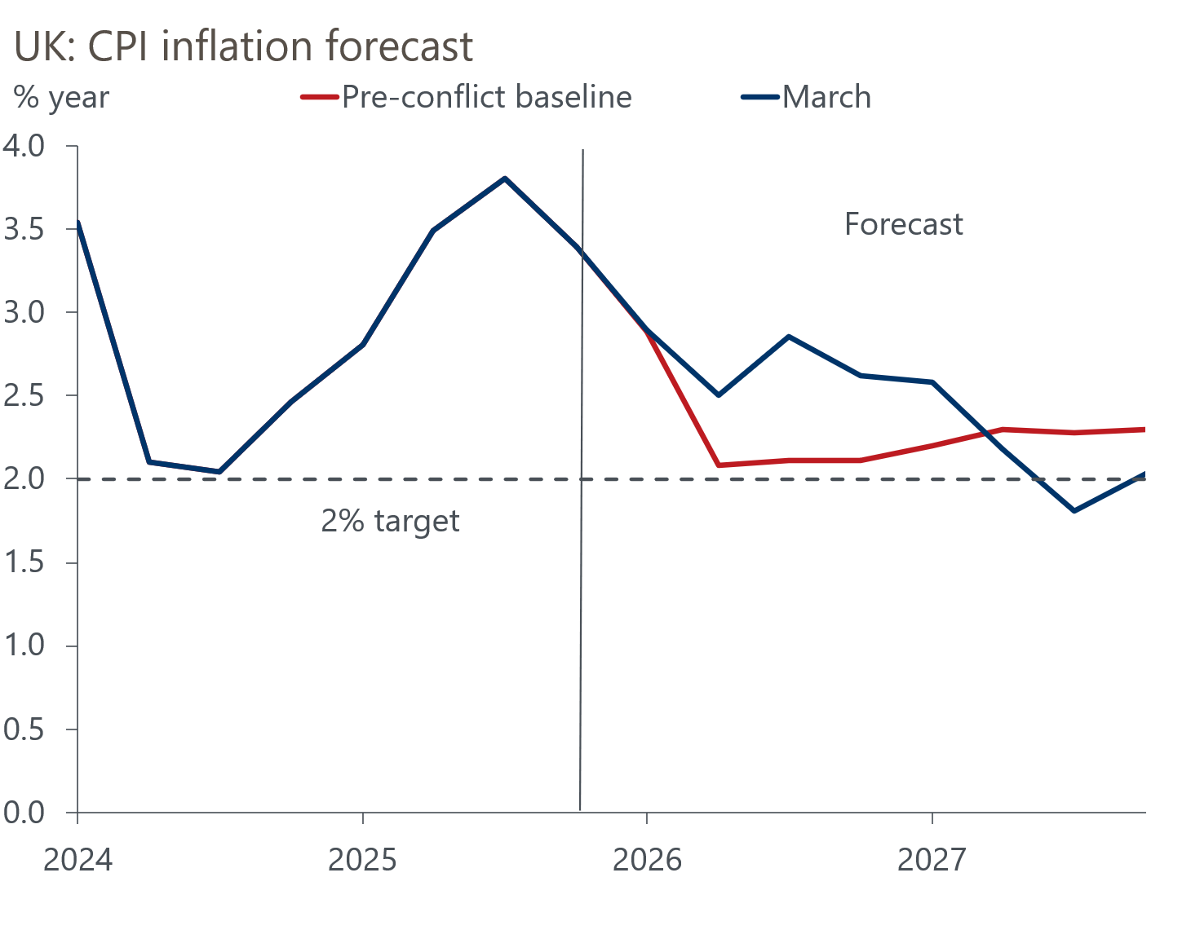
Sources: Oxford Economics, Haver Analytics

Ofgem's quarterly energy price cap mechanism means the impact of the rise in European gas prices will only be felt from July. The observation window for the July price cap has only just begun. If gas prices evolve as we expect, we estimate average household energy bills will rise by around 13.5% in July, adding about 0.5ppts to CPI inflation that month. But given we expect the increase in gas prices to be short-lived, the price cap should drop back from October.
We anticipate some passthrough of higher fuel and energy costs for businesses to other parts of the inflation basket, such as food prices and the more energy-intensive components of core inflation. However, the upward pressure on inflation from this indirect transmission channel is likely to be relatively modest, given the temporary nature of the shock. A large degree of slack in the economy will also limit the scope for firms to pass on higher input costs.
Our updated forecast will show a slightly weaker picture for GDP growth this year. The momentum behind real household income growth was already slowing, and higher inflation means we now expect real incomes to flatline this year. So, we will cut our forecast for consumer spending growth and nudge down our projection for 2026 GDP forecast by 0.1ppt to 0.8%. We still expect growth of 1.3% in 2027.
Monetary policy is also likely to be affected by this week's developments. Prior to the conflict in the Middle East, financial market pricing implied an 81% chance of a March rate cut, although we thought the decision was more finely balanced, not least because of the deep divisions in the Monetary Policy Committee. The likelihood of a period of higher inflation caused a significant repricing by markets this week. At Thursday's close, market pricing implied just a 24% chance of a March cut, with the implied probability of an April cut falling to 61% (Chart 2)
Chart 2: Market pricing has shifted away from the prospect of a March cut
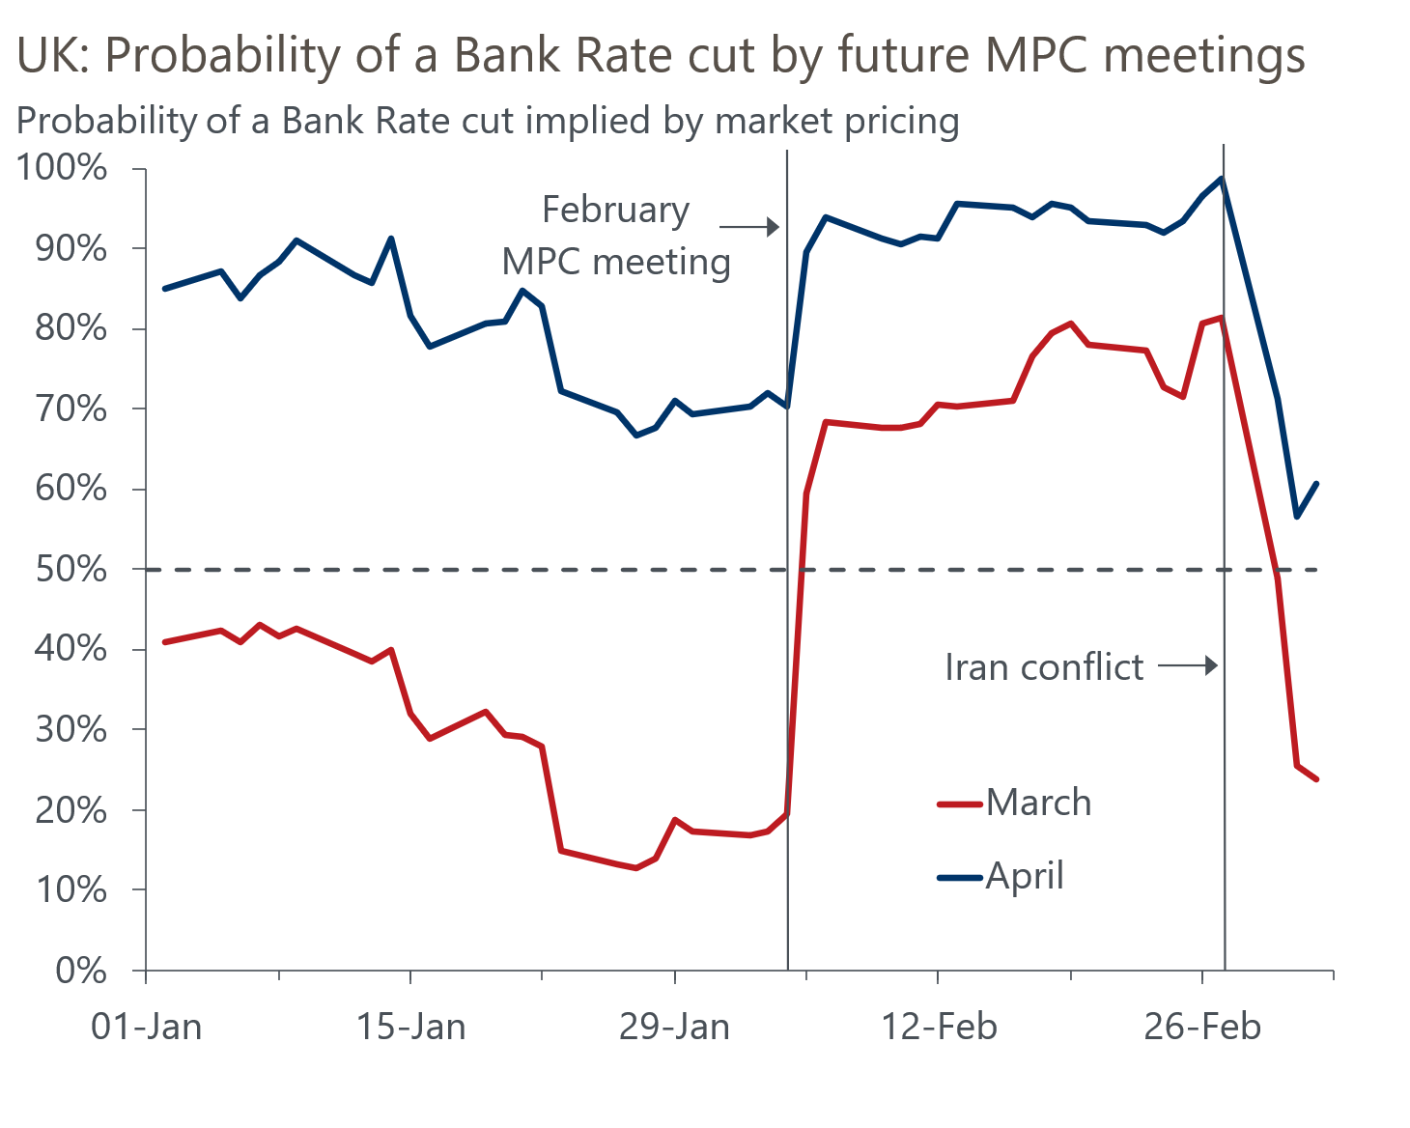
Source: Oxford Economics calculations using data from Haver Analytics
With the length and magnitude of the shock highly uncertain, and inflation expectations already at an elevated level, we agree with markets that the MPC is unlikely to cut in March. If the shock proves relatively short-lived, there's a good chance that the MPC resumes its cutting cycle either in April or June. Our new base case will still assume a second cut later this year. But if the surge in energy prices persists or expands, the MPC will be set for an extended pause. Given that policy remains restrictive, the Committee is unlikely to hike rates unless inflation expectations rise significantly.
The OBR will have plenty of time to consider the implications of the conflict ahead of its next forecast in the autumn. That update will also take on board new Office for National Statistics population projections. The OBR made some modest near-term cuts to its assumptions for net inward migration in this week's projections. But we think its assumptions still look too high and expect that the OBR will be forced to lower its profile further. This would damage growth prospects and imply a weaker outlook for the public finances.
More broadly, we remain sceptical that the fiscal plans will deliver the reduction in borrowing that the OBR anticipates. So, while the OBR's new forecast suggests there's reasonable headroom (£24bn or 0.7% of GDP), we think the UK fiscal situation is more parlous.

The week ahead
Next week's only major economic release is the GDP data for January. Output growth remained modest over the final months of 2025, and we think that story continued at the start of this year. At the sector level, unusually weak readings in December in several sectors, such as manufacturing, are unlikely to be sustained. Meanwhile, we anticipate a rebound in health sector output, after strikes by resident doctors weighed on activity in December. As a result, we estimate that GDP rose by 0.1% month-on-month in January.
Table 1: Week ahead calendar
Date | Events | Period | Measure | Unit | Previous | Forecast
Mar 13 | GDP | Jan | m/m | % | 0.1 | 0.1
Mar 13 | GDP | Jan | 3m/3m | % | 0.1 | 0.2
Mar 13 | Index of services | Jan | m/m | % | 0.2 | 0.2
Mar 13 | Index of services | Jan | 3m/3m | % | 0.0 | 0.2
Mar 13 | Manufacturing output | Jan | m/m | % | -0.6 | 0.3
Mar 13 | Manufacturing output | Jan | y/y | % | 0.4 | 1.5
Mar 13 | Industrial production | Jan | m/m | % | -0.9 | 0.3
Mar 13 | Industrial production | Jan | y/y | % | 0.4 | 0.7
Mar 13 | Construction output | Jan | m/m | % | -0.5 | 0.1
Mar 13 | Construction output | Jan | y/y | % | -0.2 | -0.2
Mar 13 | UK trade | Jan | Trade balance | £bn | -4.3 | -5.2
Mar 13 | UK trade | Jan | Visible balance | £bn | -22.7 | -23.3
Source: Oxford Economics

Key forecasts
Table 2: UK forecast overview
(Annual percentage changes unless specified)
 | 2023 | 2024 | 2025 | 2026 | 2027 | 2028
GDP | 0.3 | 1.1 | 1.3 | 0.8 | 1.3 | 1.5
Private consumption | -0.3 | -0.1 | 1.0 | 0.8 | 1.0 | 1.4
Fixed investment | 0.5 | 1.7 | 3.4 | 1.4 | 2.0 | 2.0
Government consumption | 2.1 | 2.9 | 1.7 | 2.1 | 1.6 | 1.4
Exports of goods and services | -2.3 | 1.4 | 1.6 | 0.8 | 1.0 | 1.5
Imports of goods and services | -1.6 | 2.7 | 4.2 | 0.0 | 1.1 | 1.6
Industrial production | -2.6 | -1.3 | 0.3 | 0.7 | 0.9 | 1.2
Consumer prices | 7.3 | 2.5 | 3.4 | 2.7 | 2.2 | 2.0
Unemployment rate (%) | 4.1 | 4.3 | 4.9 | 5.3 | 5.1 | 4.8
Current a/c balance (% of GDP) | -3.6 | -3.0 | -2.8 | -3.4 | -3.0 | -2.9
Government balance (% of GDP) | 5.2 | 5.3 | 5.1 | 3.5 | 3.2 | 2.8
Central bank policy rate (%, EOP) | 5.25 | 4.75 | 3.75 | 3.25 | 3.00 | 2.75
10yr govt. bond yield (%, EOP) | 3.54 | 4.57 | 4.47 | 4.38 | 3.95 | 3.60
Exchange rate (US$ per £, EOP) | 1.27 | 1.25 | 1.35 | 1.30 | 1.30 | 1.30
Exchange rate (euro per £, EOP) | 1.15 | 1.21 | 1.15 | 1.11 | 1.10 | 1.10
Source: Oxford Economics
Table 3: Quarterly forecasts for the UK
 | 2025 |  |  |  | 2026
 | Q1 | Q2 | Q3 | Q4 | Q1 | Q2 | Q3 | Q4
GDP (% year) | 1.8 | 1.4 | 1.2 | 1.0 | 0.7 | 0.7 | 0.9 | 1.1
CPI inflation (% year) | 2.8 | 3.5 | 3.8 | 3.4 | 2.9 | 2.5 | 2.9 | 2.6
Bank Rate (%, EOP) | 4.50 | 4.25 | 4.00 | 3.75 | 3.75 | 3.50 | 3.50 | 3.25
10yr gilt yield (%, EOP) | 4.70 | 4.48 | 4.70 | 4.47 | 4.50 | 4.48 | 4.45 | 4.38
US$ per £ (EOP) | 1.29 | 1.37 | 1.35 | 1.35 | 1.33 | 1.32 | 1.31 | 1.30
Euro per £ (EOP) | 1.20 | 1.17 | 1.15 | 1.15 | 1.15 | 1.13 | 1.12 | 1.11
Source: Oxford Economics

Latest Country Economic Forecast:
February 16, 2026

Recent publications

Data Insights
Middle East conflict likely to halt run of strong PMI readings
Recent rise in Manufacturing PMI is too optimistic
Mortgage activity remained weak at the start of 2026
February's PMI suggests economic momentum remains strong
Bumper January for tax receipts keeps public finances on track

Research Briefings
How will central banks respond to the Iran conflict?
OBR forecasts were out of date before they were published
Productivity may be picking up – but not in a good way
The 2026 inflation outlook is a tale of two halves
Lower immigration will hit growth and raise borrowing

Contacts

Oxford Economics' UK team
- Andrew Goodwin - Chief UK Economist - agoodwin@oxfordeconomics.com
- Edward Allenby - Senior UK Economist - eallenby@oxfordeconomics.com

